Indonesia AAC Industry Feasibility Report
of
150,000 m3/year AAC production line ( Sand based )
印尼15万立方加气砖生产线可行性报告（沙子）

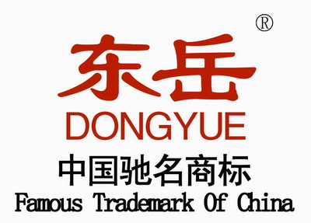
Prepared By
from Dongyue Machinery Group,China
Date:
Content 内容
Chapter I Introduction Of Dongyue Machinery Group
第一章 东岳机械集团介绍
Chapter II Impression Of AAC Light Weight Block
第二章 加气砖介绍
Chapter III AAC Industry Description
第三章 加气砖行业介绍
Chapter IV Production Processing
第四章 生产流程介绍
Chapter V Raw Materical
第五章 原材料
Chapter VI Sales Conditions
第六章 合同条款
Chapter VII General Description Of 150,000m3/year AAC Plant
第七章 年产15万加气砖工厂介绍
Chapter VIII Price For Machinery
第八章 机器价格
Chapter IX Indonesia Market
第九章 印尼市场成本分析

Chapter I Introduction Of Dongyue Machinery Group
东岳机械集团介绍
1.1 Dongyue machinery group milestone and introduction
1.1 东岳机械集团发展历程和介绍
★ German tachnolagy: dongyue cooperate with German famous company AAC- Concept GmbH to improve and upgrade its and China AAC industry tachnology;
东岳机械集团，国内唯一一家真正和德国企业合作，从而使中国加气砖技术得到质的飞跃。合作伙伴为德国卡茨贝通集团。
★ Dongyue has its own AAC block, AAC panel and sand-lime three in one plant; with rich experience in manufacturing equipment and AAC plant management, we can provide our customers with latest technical support and management experience output timely;
东岳拥有自己的加气砖，加气板，灰砂砖三线合一生产线，具有加气砖工厂丰富的管理经验，从而为客户提供最新的技术支持和经验。
★ International and national industry exchanges and promotion: host the 32nd aerated autoclaved concrete block annul meeting successfully;
成功举办中国第32届加气砖年会。
★ Abundant capital and scale strength: with registered capital of 200 million yuan, total investment of 1 billion yuan and 1500 staff, the company covers an area of 30 hectares and has 30 workshops and 8 subsidiaries; With production capacity of 5000 sets baking-free brick machine, 500 sets autoclaved aerated concrete block and plate production line, we provide customers with planning, design drawing, guiding the construction, installation, commissioning, technical teaching one-stop service.
工厂资金和规模：注册资金2亿元，总投资10亿元和1500名员工，公司占地面积30公顷，有30个车间和8个子公司；年产5000套免烧砖，500套加气砖。为客户提供工厂规划，图纸设计，建设指导，安装，调试，技术支持一站式服务。
★ Largest AAC block equipment manufacturer in China and has offices in Indonesia, India, Vietnam and other countries and more than 40 clients.
Also the largest equipment supplier in Indonesia market with lot of local experience in production and market;
中国最大加气砖制造商拥有印尼，印度，越南等办事处。同时也是印尼最大的加气设备供应商，拥有当地丰富的经验。
★ International cooperation between government and enterprise: During time of AAC annual meeting, host counsellors from 16 countries, and achieve cooperation between enterprise and governments, and further discuss the cooperation in the future;
政府和企业合作：加气砖年会期间邀请16个国家大使，实现企业和政府之间的深入合作。
★ Technical team timely support: have a lot of experienced after-sales service staff, and will provide clients with timely and professional service to ensure customer’s plant to lanch as soon as possible to earn the market; And offer feasible suggestions for production and management.

技术支持：拥有一大批经验丰富的售后服务团队，为客户提供及时的专业服务帮助客户占领市场；为生产和管理提供可行性建议。

1.2 Dongyue main worldwide AAC block market 东岳世界范围内的销售网络
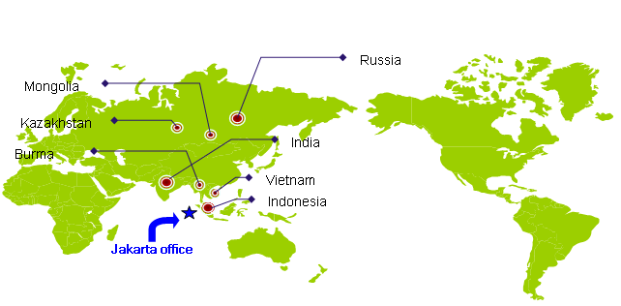

Chapter II Impression Of AAC Light Weight Block
第二章 加气砖介绍

- What Is AAC Block? 何为加气砖
Autoclaved Aerated Concrete is a high quality building material manufactured from quartz sand ,lime ,cement, aluminum compound and water several natural chemical reactions take place during the manufacturing process that account for AAC ‘s high strength ,light-weight and thermal properties. 加气砖是高层建筑优良的建筑材料，采用沙子，石灰，水泥，铝粉，石膏几种材料发生化学反应制得。具备高强度，重量轻，保温隔热等特性。
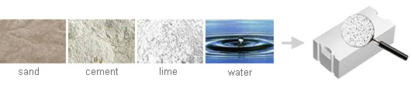
Through a manufacturing process that is lower in power consumption than that of clay bricks .it’s possible to produce 5 cubic meters of AAC from only 1 cubic meter has a high load bearing capacity ,is much lighter and can be worked in a manner similar to timber.
AAC is durable, fire retardant, vermin proof and has excellent thermal insulation properties.
该制作工艺消耗能量只有传统制作红砖的五分之一。加气砖防火，隔热特点非常突出。

- AAC Block Advantages 加气砖优点
AAC is one of the major achievements of the 20th century in the field of wall construction. It is a revolutionary material offering an unique combination of high durability and strength, low weight, unprecedented buildability and superior ecological green features.
加气砖是20世纪墙材领域主要的成就。具有革命性的意义，具有高强度，重量轻，建筑施工方便以及环保等特性。
• AAC is a high-quality, load-bearing and extremely well insulating building material produced as standard or mega blocks or panels.加气砖具有高质量，承重，绝热等特性，可做成砖或墙板。
• AAC is a long proven material. It has successfully been used in world since early last century and is now among the mostly used wall building materials in Europe with rapidly growing market shares in Asia, the Middle East and recently America.
加气砖是长期验证过的产品。在上世纪初已成功应用在世界范围，现在应用在欧洲，亚洲发展中国家，中东以及美国。
• AAC is the material of choice for all building applications, including homes, multi-family, seniors housing, hotels, commercials, schools, hospitals, sports halls, etc. –an excellent building material for all climatic conditions. It is used for all walls, external or internal, loadbearing or nonloadbearing walls, basement walls, infill walls to framed structures, party walls, fire break walls, etc. 加气砖是所有建筑物的选用材料。例如家庭，宾馆，高档社区，商业，学校，医院，体育馆。可是用各种气候的理想建筑用材。用于室内室外，承重或非承重，地下室，填充墙，防火墙等。
• AAC is a steam-cured mix of sand or pulverized fuel ash (PFA), cement, lime, anhydrite (gypsum) and an aeration agent. The high-pressure steam-curing in autoclaves achieves a physically and chemically stable product with an average density being approx. one fifth of normal concrete. AAC comprises myriads of tiny non-connecting air bubbles which give AAC its diverse qualities and make it such an excellent insulating material.
加气砖是蒸汽化合物。蒸压釜内高压蒸汽发生物理和化学变化，可使密度达到一般混凝土的5分之一。加气砖内气孔使其具有良好的耐火性。

- AAC Block Classification 加气砖等级分类
AAC Block is classified by Strength and dry density 按强度和干密度划分
By strength强度分为：A1.0，A2.0 ，A2.5 ，A3.5 ，A5.0 ，A7.5， A10;
By dry density干密度：B03，B04，B05，B06，B07，B08。

Take the following table for more information

Table 1 Block Cube Compressive Strength Unit:MPa
Strength level 强度等级 | Cube compressive strength 抗压强度（Mpa）
Strength level 强度等级 | average value no less than  平均值不小于 | single set minimum value no less than  单点强度不低于
A1.0 | 1.0 | 0.8
A2.0 | 2.0 | 1.6
A2.5 | 2.5 | 2.0
A3.5 | 3.5 | 2.8
A5.0 | 5.0 | 4.0
A7.5 | 7.5 | 6.0
A10.0 | 10.0 | 8.0

Table 2 Block Dry Density 干密度 Unit: Kg/m3
Dry density level 密度等级 |  | B03 | B04 | B05 | B06 | B07 | B08
Dry density  Level 密度 | Super product（A） 高等级 ≤ | 300 | 400 | 500 | 600 | 700 | 800
Dry density  Level 密度 | Qualified product（B）  合格品≤ | 325 | 425 | 525 | 625 | 725 | 825

Table 3 Block Classified By Strength And Dry Density 按强度和干密度分类
Dry density level 干密度 |  | B03 | B04 | B05 | B06 | B07 | B08
Strength  level 强度等级 | Super product（A）优等品 ≤ | A1.0 | A2.0 | A3.5 | A5.0 | A7.5 | A10.0
Strength  level 强度等级 | Qualified product（B）  合格品≤ | A1.0 | A2.0 | A2.5 | A3.5 | A5.0 | A7.5

Table 4 Finished Block Dimension 成品尺寸
Length 长 | Width宽 | Height高
600mm | 100mm  125mm  150mm  200mm  250mm  300mm | 75mm  100mm  150mm  200mm  250mm  300mm

Chapter III AAC Industry Description
第三章 加气砖行业介绍

1. AAC Industry Characteristics 加气砖行业特点
★ Energy conservation and environment-friendly industry: wide raw material sources, can use sand or fly ash, reduce waste, and production is low energy consumption;
节能环保行业：广泛的原材料可使用沙子或粉煤灰，低耗能。
★ AAC block characteristics: Light weight, good thermal insulation performance, good fireproof performance and do not send out harmful gas, good machinability and absorption function, convenient construction, improve construction efficiency;
加气砖特点：质轻，隔热，防火，无毒，易于加工，吸水性好，建筑施工方便，提高施工效率。
★ Long investment cycle: generally from inspection to final production needs almost a year; 1 to 2 months, production about 3 months, shipping a month, installation for 3 months, 1 months training and trial production;
投资周期：从施工到投产大概需要一年：前期准备1到2个月；设备制造3个月，运输一个月，安装3个月，1个月培训，1个月试生产。
★ Features of aerated autoclaved concrete block equipment industry in China: it has been a very mature equipment manufacturing industry i with a lot of manufacturers, but the quality is uneven; Many equipment manufacturers is of small scale, lack of after-sales service and production experience; Project cycle is long, uncertain factors more, so it is better to choose the big company with experience for cooperation for a long time;
加气砖中国：设备制作很成熟，质量不一；众多设备厂商规模小，无售后和生产经验；由于该项目周期较长，建议选择有经验的大公司作为合作伙伴。

2. Customer purchasing focus 客户购买关注点
★ The equipment manufacturer's overall size, strength and credibility
★ Whether have sample production line and the running situation of its existing customers
★ Local market and overseas market development experience
★ Technical team, after-sales timely support
设备制作商规模，实力，信用。
是否有样本线及当地运行的客户工厂。
当地市场及国际市场经验。
技术团队，售后支持。

Chapter IV Production Processing
第四章 生产工艺

4.1 Processing description
A . Fly ash or sand will be grinded by ball mill and then made into slurry and stored in slurry tank.
B. The lime stone will be crushed by jaw crusher and lifted into the lime silo through elevator，then will be
grinded into powder by dry ball mill machine through belt conveyor。The lime powder will be stored in the
lime powder silo for reservation.
C. Raw material preparation process transportation section is equipment with dust cleaner to ensure
environment from pollution.
D. After raw material storage，the slurry、cement、lime powder and aluminum powder are weighed and then
poured into the pouring mixer for mixing, finally be poured into mould box.
E. The batching mixing and pouring system is controlled by PLC automatical control system. According to
raw material chemical test form accurate formula.
F. After completing batching process，it comes to the standstill for pre-curing process. Mixed slurry in the
mould box expands because of the hydrogen produced by the chemical reaction of lime aluminum and
water. After foaming，it becomes into block cake. The block cake complete the harden process to
achieve the cutting requirements at certain temperature. And the mould box comes out of the cutting
area and waiting for cutting.
G. Mould box is transported to the cutting area by the reversal crane and the crane reversal the mould 90
degrees and put it on the cutting car，the cranes manipulator open the mould box and demould
Automatically. Then put the block cake with slide pallet on the first cutting car and the block cake do the
six point cutting. First，the first cutting car with the block move to the level cutting machine. The level
cutting is finished by the cutting blade and cutting wire tensed by air cylinder. Vertical cutting frame lands
from top to bottom automatically and cutting wire move softly and finish vertical cutting. The cutting
replacement equipment starts。The cutting under the cutting machine places its oil cylinder，jack the
block and the first cutting car returns to its starting position and carries next block cake. The second
cutting car will replace the first cars position and carry the block cake to the group crane.
H. The crane lift the block cake to the reversal table and remove the bottom waste material by it. Then the
grouping crane will lift the block the steam trolley and enter the autoclave through automatic entering
autoclave device.
I. The finished products are pulled out of the autoclave by the windlass and move to the transportation
crane. The crane will take the cake to separating machine area to separate the block. Separating
machine can use a fixed style or an moving type. At the same time，steam trolley return to the font of the
autoclave through recycling rail and wait for carrying new block cakes.
J . Separated block will move to finished crane。At the same time，the side pallet will be cleaned，and go
to the reversal crane and make an empty mould with a cleaned mould for pouring.
K . Waste generated in the production process is once again added to the new production process through
waste mixing pouring system. No waste water，waste gas generated. The entire line will continue and
repeat the above production process to adopt the needs of different annual production.
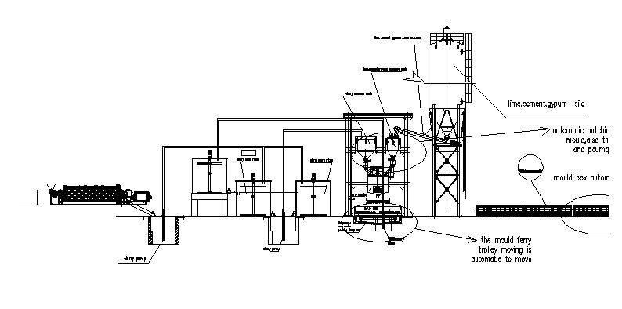

4.2 Production processing chart

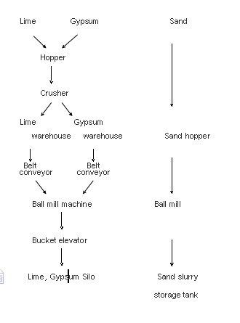

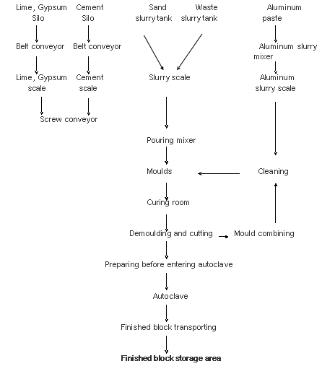

4.3 Main technological cycle
Mixing cycle: 6 - 7 min
Pouring temperature: 40 - 45 ℃
Pre-curing time: 2 - 3 h
Environment temperature for curing: 45 - 55 ℃
Body strength after curing: 0.15 - 0.18 MPa

Autoclave steaming total 12 hours
Autoclave loading /unloading: 0.5 h
Vacuuming: 0.5 h (0 - 0.06 MPa)
Pressure up: 1.5 h (0.06 - 1.3 MPa)
Constant pressure: 8 h (1.3 MPa)
Pressure down: 1.5 h (1.3 - 0 MPa)
4.4 Persons for each operation process 人员分配
Job 工种 | Position 位置 | Number of people 数量
Loading material 上料 | Forklift driver | 1
Matching material 配料 | Pouring building 浇筑楼 | 1
Cutting machine 切割 | Ground handling 地面 | 1
Reversal crane 翻转吊 | Ground handling 地面 | 1
Blocks transporting crane 编组吊 | Ground handling 地面 | 1
Reorganising mould and painting oil模箱涂油 | Ground handling 地面 | 2
Preparing to enter autoclave 编组入釜 | Ground handling地面 | 1
Boiler worker 锅炉工 | Operating with license 锅炉 | 1
Autoclave 蒸压釜工 | open and close autoclave door 开闭蒸压釜 | 1
Electrician 电工 | Daily Circuit checking and maintenance 日常线路检修和维护 | 1
Finished blocks area 成品区 | Forklift driver 叉车司机 | 1
Packing system包装区 | Packing area包装区 | 5

Chapter V Raw Materical
For reference,the materials components could be change according fact.
1. Sand (沙子)- 60-70%
 |  | Super Grade | First Grade | Qualified product
SiO₂ | ≥ | 85% | 75% | 65%
CI- |  | 0.02% | 0.03% | 0.03%
Mica(云母) | ≤ | 0.5% | 0.5% | 1%
SO₃ | ≤ | 1% | 1% | 2%
clay | ≤ | 3% | 5% | 8%
K₂O+Na₂O | ≤ | 1.5% | 3% | 5%

2. Lime (石灰)- 15-25%
Item | Grade
Item | Super Grade |  | First Grade | Qualified  product
A(CaO+MgO) Quality Fraction % | ≥ | 90 | 75 | 65
MgO Quality Fraction % | ≤ | 2 | 5 | 8
SiO₂ Quality Fraction % | ≤ | 2 | 5 | 8
CO₂ Quality Fraction % | ≤ | 2 | 5 | 7
Digestion speed ,min | ≤ | 5-15
Digestion temperature , ℃ | ≥ | 60-90
Undigested residue quality fraction ,% | ≤ | 5 | 10 | 15
Fineness (0.080 square hole sieve left amount) % | ≤ | 10 | 15 | 20

3.Cement (%)(水泥)- 10-15%
SiO2 | Al₂O₃ | Fe₂O₃ | CaO | MgO | C₃S | C₂S | C₃A | C₄AF
21-23 | 5-7 | 3-5 | 64-48 | 4-5 | 44-59 | 18-30 | 5-12 | 10-18

4. Plaster（石膏）-3-5%
CaSO4 | ＞ | 70%
MgO | ＜ | 2%
Chloride（氯化物） | ＜ | 0.05%
Preferably ground residue 90µm（可接受残渣） | ＜ | 10-15%

5. Aluminium（铝）0.074%
Type and recommendation for supply depend on raw materials and mix formula
Metal Content | Approx. | >=65% | Powder 铝粉

Chapter VI Sales Conditions
6.1 Payment Terms
Total contract price will be paid by the seller to the buyer as per the followings:
30% of total contract price will be paid by T/T as down payment.
70% of total contract price will be paid by T/T or irrevocable L/C at sight against the shipping documents.
Or other both side agreed terms.

6.2 Delivery Terms
All machines will be ready for delivery in seller’s workshop within 70 days after the contract come into force.

6.3 Packing
To be packed suitable for long distance ocean transportation and well protected against damage, moisture, shock, rust and handling.
The equipment will be kept in covered and guarded areas when it arrives at the Buyer’s plant. All the precautionary measures necessary for the correct protection of the materials will be taken while awaiting its installation.

6.4 Warranty
The seller side shall guarantee that all the contract equipment are completely brand-new and conform to the technical specifications.
The mechanical guarantee on machinery and equipment shall be one year from the acceptance date. During the warranty period, if the accessories or equipment are damaged, due to the buyer’s insufficient maintenance or improper operation of the equipment, the seller will replace or repair it at buyer’s charge. If the said damages are due to faults in design, poor quality or workmanship, the Seller will replace or repair it at his own cost.

6.5 Installation
Includes the following phases:
a. Positioning of the equipment in conformity with the plant layout,
b. Assembling of what is necessary for the completion,
c. Connection with various electrical, pneumatic, or other supply sources,
d. Adjustment of the equipment; leveling; running of motors,
e. Idling test of the equipment.
f. USD50/person/day installation and commissioning charges will be at cost of buyer.

6.6 Start-Up
This includes all actions necessary to put the contract equipment in operation until the completion of the production acceptance standards.
Upon what above-mentioned processing finish, the Acceptance Certificate of the Plant shall be Issued.
6.7 Training
Buyer’s personnel (less than 3 persons) can be dispatched for training at one bricks factory in seller’s country and, further trained at buyer’s contract plant.

6.8 Others
a. All taxes and duties including government charge on services, import duty, income tax, and so on, incurred in the Buyer’s country during the implementation of the contract shall be borne by the buyer.
b. The charges for round trip tickets between China and buyer’s working site, the board and lodging for the seller’s engineers and technicians, local transportation are to be paid by buyer.

6.9 Validity of Quotation
3 weeks from the date of quotation.

Chapter VII General Description Of 150,000m3 AAC Plant
7.1 This project is designed for production of AAC block with annual output 150,000m3.
7.2 Main technical index:
Product | AAC block (ALC)
Capacity | 150,000 M³ / year
Cake size | 4.2 x 1.2 x 0.6 M³
Finished product size | 75~200 x 200 x 600 mm
Density | 500～650 Kg/m3 (Varied as different formula)
Block strength after autoclaved | Average ≥ 3.5 MPa, minimum ≥ 2.8 Mpa
Autoclaving cycle | 12 h
Steam working pressure | ~1.2 MPa
Working days | 300 days / year
Working shifts | 2 - 3 shifts / day
Working hours | 7.5- 10 hours / shift
Total Land requirement | ≥ 2 hectare ( can adjust according real land conditions)
Workshop area | 6000 - 7000 m2
Total power | 650 KVA

7.3 Raw material consumption （ take 600kg/m3 block for reference）
Sand | 180 - 200 T/day
Lime | 60 - 70 T/day
Cement | 30 - 40 T/day
Gypsum | 9 - 10 T/day
Auluminium | 200 - 250 kg/day
Water | 200 -300 m3/day

7.4 All the technical data only depend on mature technical formulas.
7.5. Power Supply: 3-phrase & 5-wire, 380V/50Hz
7.6. Fuel: Coal (caloric value: 5,600kcal/kg)

Exclusive
1. Transformer substation, electric cabinet.
2. Tools and materials for installation, i.e.:welding rod, oxygen,acetylene, lubrication oil or grease, last
paint for equipments
3. A. Wires: Between each of electric equipment, each of control panels, center control and each.
B. Cable: From transformer to electric cabinet, cabinet to electric control, electric control to each
equipment department.
4. Other piping, valves, rails, thermal insulation.
A. Rail: Curing room, before and after autoclave and all transition rails
B. Steam piping: Curing room, from boiler to autoclave
C. Boiler: Water feeding, steam exit of boiler to distributor, distributor to each of inlet autoclave.
D. Slurry piping: All of pipes for slurry.
E. Water piping: All of pipes for water (up and down).
F. Compressed piping: All of pipes for compressed air.
All of above pipings have to be equipped with necessary flange, T-connection, elbow, reducing
fittings etc.
G. Valves: All of valves fit in pipings, such as steam pipes, slurry pipes, water pipes distribution
pipes, compressed pipes.
H. Thermal insulation: Autoclave and steam pipings
5. Steel structure: platform, ladder, handrail, silo, embedded parts.
6. Illumination, heating, water supply-drainage.
7. Foundation and civil work.

Remark: All the above items shall be subjected to final design and engineering.

Chapter VIII Price For Machinery
8.1 General price list
No. | Production section | Total price （ USD） | Remark
100 | Raw material dealing and store process | 189769.00
200 | Material measure、batching 、pouring process | 59146.00
300 | Pre-curing section | 323280.00
400 | Cutting process | 125920.00
500 | Autoclaving and curing process | 124638.00
600 | Control system | 98110.00
700 | Laboratory equipment | 7896.00
800 | Other cost | 9600.00
900 | Autoclaving device | 359723.00
1000 | Boiler | 0.00 | Optional, not  included in total
1100 | Auxiliary material in workshop | 0.00 | Supplied by client
1200 | Other equipment | 0.00 | Supplied by client
Total EXW factory price: USD |  | 1298082.00
Total FOB Qingdao price: USD

Remark:
1) The quotation has not included auxiliary equipments and materials that might be needed during commissioning.
2) Before installation, necessary facilities for water, electricity, and compressed air supply must be provided by the buyer to the jobsite positions appointed by the seller.
3) All the civil works and foundation construction should be done by the buyer.
4) The above price is on the basis of the current exchange rate, i.e. 1USD=6.20RMB. The price will vary with the exchange rate on the date of signing the contract.

Chapter IX Indonesia Market
第九章 印尼市场成本
AAC Block production cost per cubic meter in Indonesia 印尼市场每立方成本
9.3 Profit And ROI
NO. | ITEM BAHAN成本 | QTY  数量 | SAT.单位 | UNITE PRICE单价（印尼盾） | TOTAL HARGA总价
1 | PASIR SILICA (SILICA SAND)沙子 | 450 | KG | 250 | 112,500
2 | CaO (CALCIUM OXIDE)  石灰 | 120 | KG | 1000 | 120,000
3 | CEMENT水泥 | 40 | KG | 1100 | 44,000
4 | GYPSUM石膏 | 5 | KG | 2,000 | 10,000
5 | MOULD OIL脱模油 | 1 | KG |  | 2,500
6 | Al2O3 (ALUMINIUM POWDER)铝粉膏 | 0.5 | KG | 44100 | 22，275
7 | AIR (WATER)水 | 0.3 | T |  | 9,000
8 | BATU BARA (COAL)煤 | 30 | KG |  | 30,000
9 | UPAH PEKERJA (LABOUR COST)人工费 | 0.12 | MD | 100,000 | 12,000
10 | LISTRIK (ELECTRICITY)电力 | 28 | KWH | 700 | 26,611
11 | SUBTOTAL (Rp)总价 |  |  |  | 388,886
12 | ATAU (USD)总价美金/每立方米 |  |  |  | 41
Note: exchange rate 1 : 9500 汇率按
A. Locaac block price 650,000 - 700,000 Rp/M3, take 650,000Rp for eg, that is 68USD( exchange rate
1 : 9500) ; 当地市场销售价出厂价为650000到700000印尼盾，合计人民币68美金印尼盾，414.8元每立方。
B. Profit per m3 68USD - 41USD= 27 USD; 每立方利润27美金。
C. Profit rate ( interest rate, tax, equipment depreciation not included ) 27 ÷ 41 * 100% = 65.9% 利润率 65.9%
D. Total profit ( Regardless of interest rate, tax, equipment depreciation ) ( USD)
每年全部利润 150,000 * 27 = 4,050,000 USD=24,705,000RMB

